Create a page with the following things on it:

1.a) Create a slider to increase and decrease the font size of the “Test Test Test”. Use img.svg for this.

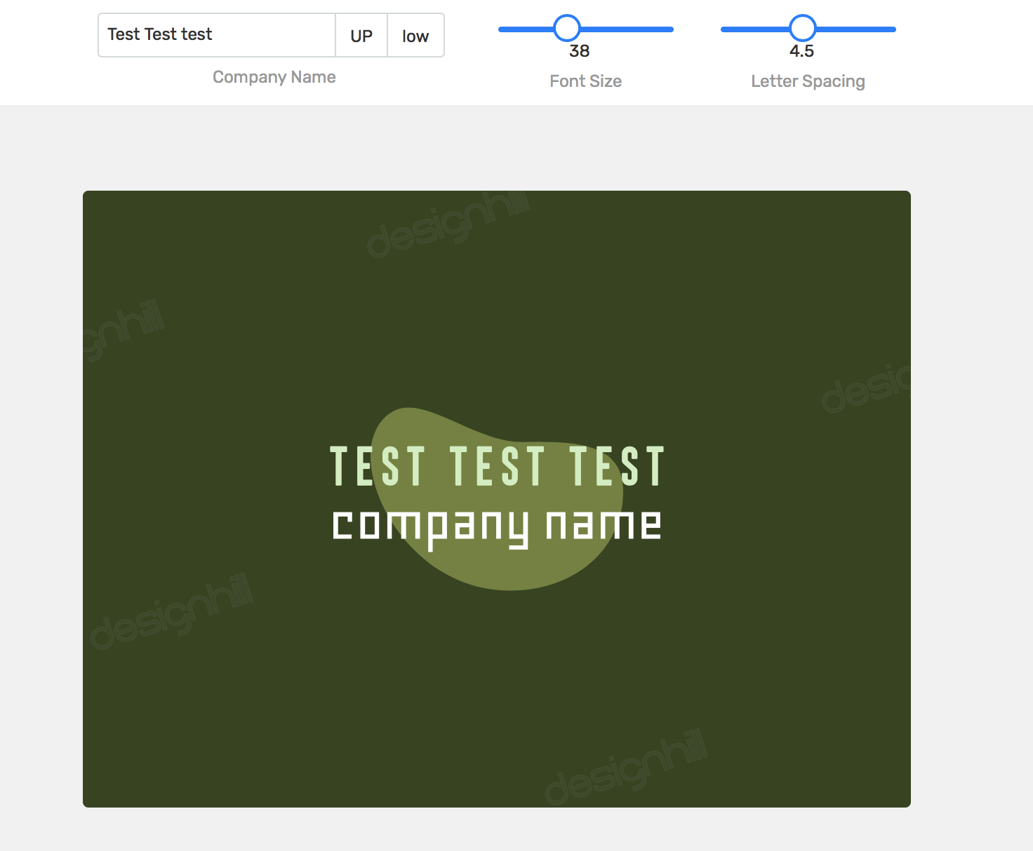

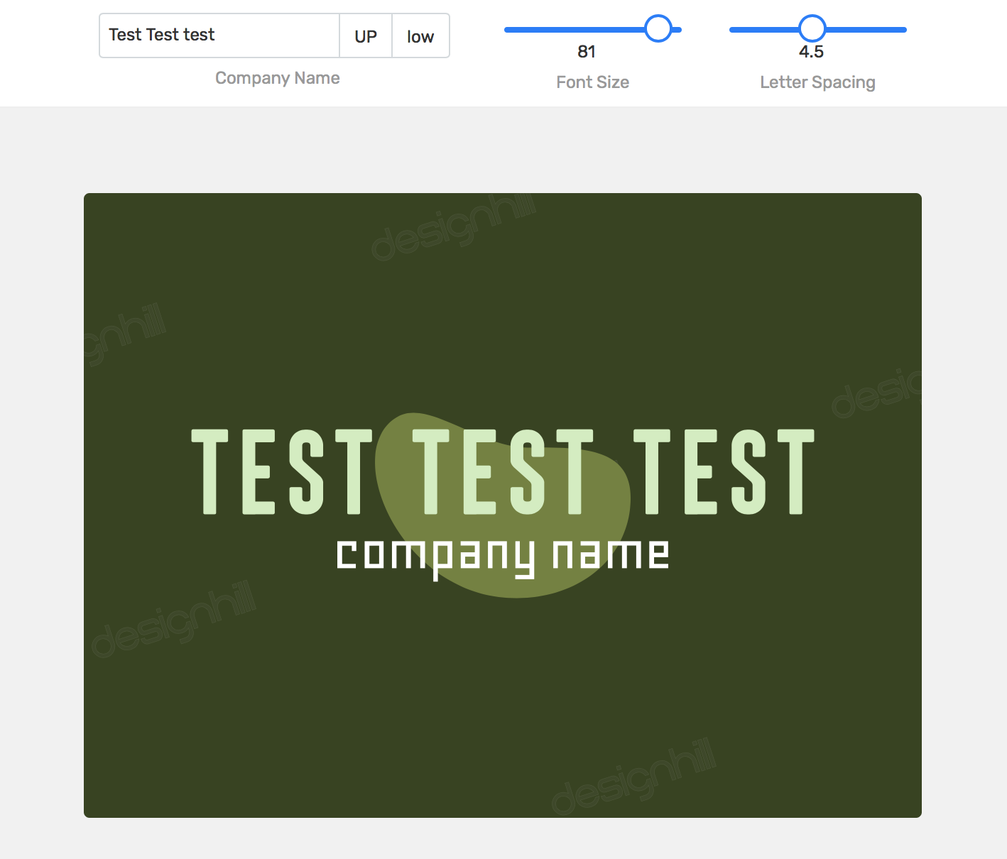

1.b) Also make sure the data persists on refresh.

2. Add the img.svg image on top of the tshirt image twice, below is the final version of the image.

<https://cdn1.designhill.com/assets/dh/images/logo-maker/preview/img7.jpg?ver=2.8.66>

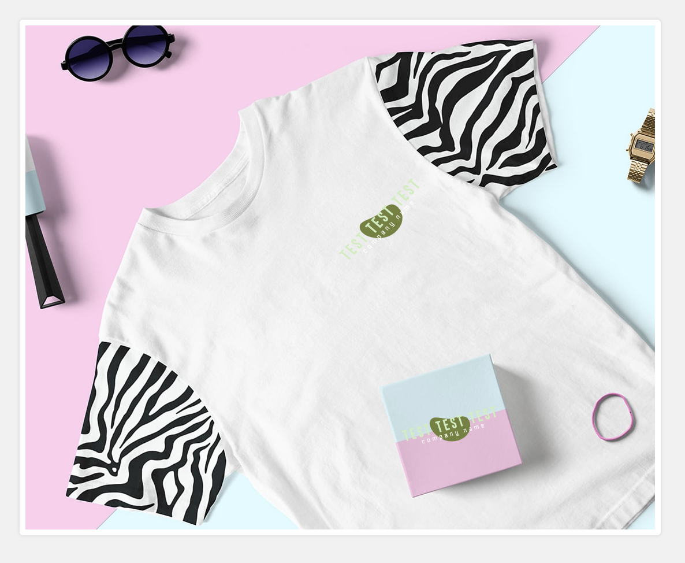

3. Create two sections with same effects which need to be responsive also. Check out this page: <https://www.designhill.com/social-media-subscription>

Starting from “WHAT DO YOU GET WITH OUR SOCIAL MEDIA SERVICES?” till “WHAT ARE DIFFERENT PRICING PACKAGES?”

